NITROGEN BALANCE IN FISHES
Submitted By:
Harsh Trivedi
Roll no.: COFS012518
Batch : 2025-29
Submitted To:
Dr. Mohd Ashraf Malik
Assistant Professor-cum-Junior Scientist
(Department of Fish Physiology and Biochemistry)

Introduction
Nitrogen is one of the most essential elements required for life. In fishes, it is a major component of proteins, amino acids, enzymes, hormones, nucleic acids, vitamins, and many structural and functional molecules. Since proteins constitute the largest nitrogen-containing compounds in the body, nitrogen metabolism is closely linked with protein digestion, growth, tissue repair, reproduction, and energy metabolism.
Nitrogen balance is the relationship between the amount of nitrogen entering the fish's body through food and the amount leaving the body through excretion.
Nitrogen Intake = Nitrogen Loss through Gills + Urine + Feces
When nitrogen intake equals nitrogen loss, the fish is in nitrogen equilibrium.
Efficient nitrogen utilization is one of the most important factors determining growth performance and feed efficiency in aquaculture.
Sources of Nitrogen
The primary source of nitrogen is dietary protein obtained from natural food organisms and formulated feeds.
Common protein sources include:
- Fish meal
- Soybean meal
- Groundnut meal
- Insect meal
- Animal protein by-products
- Plant protein ingredients
- Single-cell proteins
The quantity and quality of dietary protein determine nitrogen intake and ultimately influence growth and nitrogen retention.

Fate of Dietary Protein in Fish
After ingestion, dietary proteins undergo digestion and absorption before being utilized by the body.
Protein Digestion
Dietary Protein = Proteases (Pepsin, Trypsin, Chymotrypsin) - Peptide- Amino Acids-
Absorption through Intestinal Wall- Blood Circulation- Body Tissues

Fate of Absorbed Amino Acids
The absorbed amino acids have several possible fates.
1. Protein Synthesis
Most amino acids are used for:
Muscle development , Growth , Tissue repair , Organ development , Structural proteins , Enzyme synthesis, Hormone synthesis
Antibody production This process results in nitrogen retention inside the body.
2. Energy Production
When carbohydrates and lipids are insufficient, amino acids are broken down for energy. Their carbon skeleton enters metabolic pathways such as the Krebs cycle, gluconeogenesis, or lipid synthesis.

3. Nitrogenous Waste Formation
The amino group (-NH₂) is removed by deamination, producing ammonia (NH₃) and a carbon skeleton. The carbon skeleton is used for energy, while ammonia is transported to the gills for excretion.

Nitrogen Intake
*Nitrogen enters the body mainly through dietary proteins.
After digestion: Protein – Peptides-- Amino Acids –Absorption-- Protein Synthesis / Energy Production
Higher quality protein improves: Protein deposition, Growth, Feed efficiency, Nitrogen retention
Poor-quality protein increases nitrogen loss.

Nitrogen Assimilation
*Assimilation is the incorporation of absorbed amino acids into body proteins.
Nitrogen is retained for: Muscle growth, Organ formation, Enzymes, Hormones, Reproductive tissues, Immune proteins.
Young fish have higher nitrogen assimilation because of rapid growth.
Nitrogen Losses
Not all dietary nitrogen becomes body protein.

Not all dietary nitrogen is retained as body protein; a significant portion is excreted through different routes.
Nitrogen is lost through:
1. Gill Excretion (Major Route):
About 60-90% of nitrogen waste is excreted as ammonia through the gills in most teleost fishes.
Pathway:
Protein → Amino Acids → Ammonia → Blood → Gills → Water
2. Urinary Nitrogen:
Small amounts of nitrogen are excreted in urine as ammonia, urea, creatinine, and other nitrogenous compounds.
3. Fecal Nitrogen:
Feces contain undigested protein, digestive enzymes, intestinal mucus, sloughed epithelial cells, and microbial biomass. High fecal nitrogen indicates poor feed digestibility.
4. Other Minor Losses:
Small quantities of nitrogen are also lost through skin mucus, reproductive products, and damaged tissues.
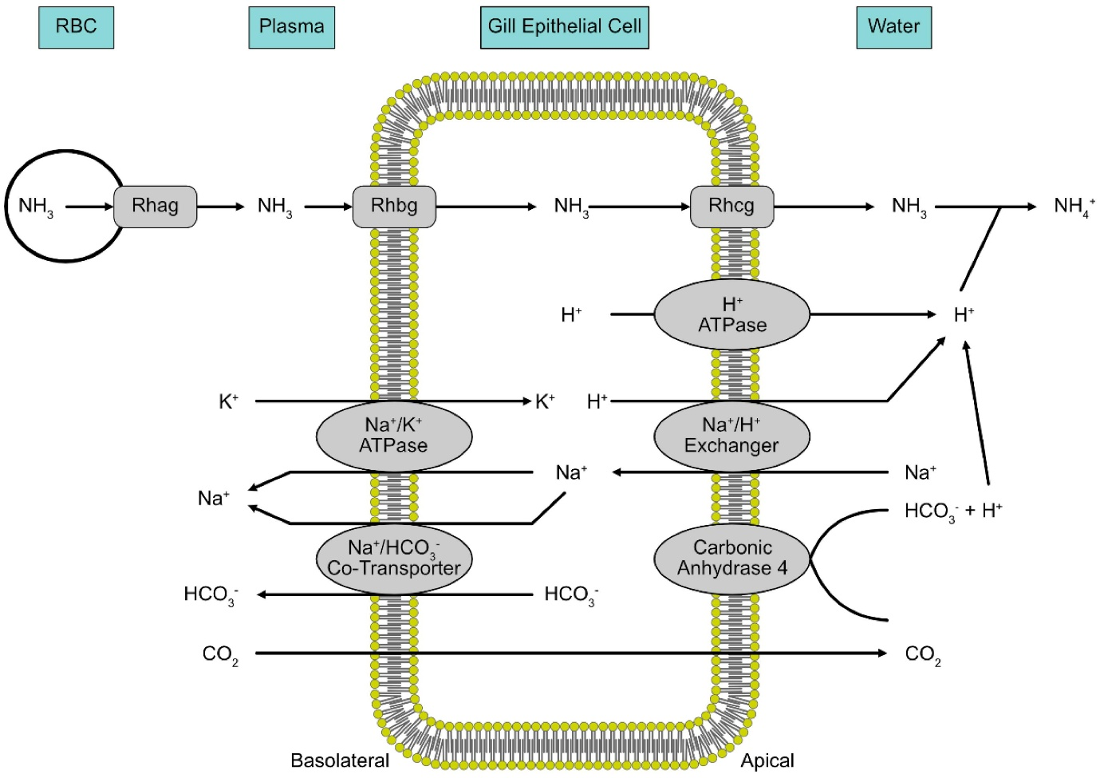
Ammonia Formation
Excess amino acids undergo deamination.
Reaction: Amino Acid → Carbon chain + NH₃
The carbon chain is used for:
- ATP production
- Glucose formation
- Fat synthesis
The released ammonia is highly toxic and therefore must be removed continuously.
Why is Ammonia Toxic?
Ammonia is the most toxic nitrogenous waste because:
- It disturbs acid-base balance.
- It increases blood and intracellular pH.
- It interferes with ion transport (Na⁺ and K⁺).
- It disrupts normal cellular metabolism.
- It affects nervous tissue and respiration.
Therefore, fishes rapidly eliminate ammonia through the gills.
Urea Production
Some fishes, particularly Elasmobranchs (sharks and rays), convert ammonia into urea.
Advantages:
- Less toxic
- Easier to store temporarily
- Helps maintain osmotic balance.
However, synthesizing urea requires considerable metabolic energy (ATP).
Urea is transported by:
- Passive diffusion
- Urea transporter proteins present in liver cells, red blood cells, and gill cells.
Transport of Ammonia
Ammonia produced in muscles and liver enters the bloodstream.
Blood carries ammonia to the gills where it leaves the body through:
1. Direct diffusion of NH₃
2. Diffusion of NH₄⁺
3. Na⁺/NH₄⁺ exchange transporters
This continuous excretion maintains internal nitrogen homeostasis.

Types of Nitrogen Balance
1. Positive Nitrogen Balance- (Nitrogen Intake > Nitrogen Loss)
Occurs during:
1. Juvenile growth
2. Tissue repair
3. Recovery from disease
4. Muscle development
5. Pregnancy in live-bearing fishes
Effects:
- Increased protein deposition
- Rapid growth
- Better feed conversion
2. Neutral Nitrogen Balance- (Nitrogen Intake = Nitrogen Loss)
Occurs in:
1.Healthy adult fish
2.Maintenance stage
3.Body protein remains constant.
3. Negative Nitrogen Balance- (Nitrogen Loss > Nitrogen Intake)
Occurs during:
Starvation, Fasting , Protein deficiency , Disease , Stress, Poor nutrition
Consequences:
- Muscle wasting
- Reduced growth
- Poor immunity
- Weight loss
- Reduced reproductive performance
Nitrogen Budget in Fish
Nitrogen consumed through feed has three major fates:
1. Nitrogen Intake (100%)
2. Body Protein Retention (Growth)
3. Gill Nitrogen Loss (Ammonia)
4. Urinary Nitrogen
5. Fecal Nitrogen
This relationship forms the basis of nitrogen budgeting in aquaculture.

Factors Affecting Nitrogen Balance
Major factors include:

Dietary protein level, Protein quality , Amino acid balance , Dietary energy , Fish age, Species, Feeding rate, Water temperature , Water quality, Stress , Disease , Digestibility of feed , Fasting period.
Balanced protein and adequate energy improve nitrogen retention by producing the protein-sparing effect (the physiological process where the body burns carbohydrates and fats for energy instead of breaking down valuable muscle protein), where carbohydrates and lipids provide energy instead of amino acids being broken down.
Importance of Nitrogen Balance in Aquaculture
Maintaining proper nitrogen balance is essential because it:
- Maximizes growth rate
- Improves feed conversion ratio (FCR)
- Enhances protein retention
- Reduces feed cost
- Minimizes ammonia pollution
- Maintains water quality
- Reduces disease susceptibility
- Improves survival
Proper feed formulation, controlled feeding, biological filtration, aeration, and regular water exchange help maintain an efficient nitrogen balance.

